Ex. No. : 04 Date :
Register No. : 221701037 Name : MOHAN VAITHYA

Android Fragments
Aim
Develop an android application to create two activities named as Student Basic Details (Register No., Name, Department) and Student Mark Details (SSLC, HSC, UG). Write an android code to combine these two activities in a single screen using an android fragment.
Procedure:
Step 1 : File → New Project
Provide the application name (e.g.,"AndroidFragments") and click “Next”.
Step 2 : Select the target Android devices
Select the minimum SDK to run the application. Click “Next”.
Step 3 : Choose the activity for the application
By default, choose “Blank Activity”. Click “Next”.
Step 4 : Enter activity name and click “Finish”.
Step 5 : Edit the program
Create multiple fragments and define their layouts and logic separately.
Manage fragment transactions in MainActivity.kt to switch between them.
Step 6 : Run the application
Two ways to run the application:
1. Running through emulator
2. Running through mobile device
AndroidManifest.xml

<?xml version="1.0" encoding="utf-8"?>
<manifest xmlns:android="http://schemas.android.com/apk/res/android"
xmlns:tools="http://schemas.android.com/tools">

<application
android:allowBackup="true"
android:dataExtractionRules="@xml/data_extraction_rules"
android:fullBackupContent="@xml/backup_rules"
android:icon="@mipmap/ic_launcher"
android:label="@string/app_name"
android:roundIcon="@mipmap/ic_launcher_round"
android:supportsRtl="true"
android:theme="@style/AndroidFragments"
tools:targetApi="31">
<activity
android:name=".MainActivity"
android:exported="true">
<intent-filter>
<action android:name="android.intent.action.MAIN" />

<category android:name="android.intent.category.LAUNCHER" />
</intent-filter>
</activity>
</application>

</manifest>

Activity_main.xml

<?xml version="1.0" encoding="utf-8"?>
<LinearLayout
xmlns:android="http://schemas.android.com/apk/res/android"
xmlns:tools="http://schemas.android.com/tools"
android:layout_width="match_parent"
android:layout_height="match_parent"
android:orientation="vertical"
tools:context=".MainActivity">

<!-- App Title Bar -->
<TextView
android:layout_width="match_parent"
android:layout_height="wrap_content"
android:background="@color/purple_500"
android:padding="16dp"
android:text="Android Fragments"
android:textColor="@android:color/white"
android:textSize="18sp"
android:textStyle="bold" />

<!-- Container for the Basic Details Fragment -->
<FrameLayout
android:id="@+id/fragment_container_basic_details"
android:layout_width="match_parent"
android:layout_height="0dp"
android:layout_weight="1" />

<FrameLayout
android:id="@+id/fragment_container_mark_details"
android:layout_width="match_parent"
android:layout_height="0dp"
android:layout_weight="1" />

</LinearLayout>
fragment_basic_details.xml

<?xml version="1.0" encoding="utf-8"?>
<LinearLayout
xmlns:android="http://schemas.android.com/apk/res/android"
android:layout_width="match_parent"
android:layout_height="match_parent"
android:orientation="vertical"
android:padding="16dp">

<!-- Section Title -->
<TextView
android:layout_width="match_parent"
android:layout_height="wrap_content"
android:text="Student Details"
android:textSize="20sp"
android:textStyle="bold"
android:gravity="center"
android:layout_marginBottom="8dp" />

<TextView
android:layout_width="match_parent"
android:layout_height="wrap_content"
android:text="Basic Details"
android:textSize="18sp"
android:gravity="center"
android:layout_marginBottom="16dp" />

<!-- Register Number -->
<LinearLayout
android:layout_width="match_parent"
android:layout_height="wrap_content"
android:orientation="horizontal"
android:layout_marginBottom="8dp">

<TextView
android:layout_width="100dp"
android:layout_height="wrap_content"
android:text="Register No."
android:textSize="14sp" />

<EditText
android:id="@+id/editTextRegisterNumber"
android:layout_width="match_parent"
android:layout_height="48dp"
android:hint="Register Number"
android:inputType="text"
android:background="@null"
android:textSize="14sp"
android:minHeight="48dp"
android:paddingTop="8dp"
android:paddingBottom="8dp" />
</LinearLayout>

<View
android:layout_width="match_parent"
android:layout_height="1dp"
android:background="#CCCCCC"
android:layout_marginBottom="8dp" />

<!-- Name -->
<LinearLayout
android:layout_width="match_parent"
android:layout_height="wrap_content"
android:orientation="horizontal"
android:layout_marginBottom="8dp">

<TextView
android:layout_width="100dp"
android:layout_height="wrap_content"
android:text="Name"
android:textSize="14sp" />

<EditText
android:id="@+id/editTextName"
android:layout_width="match_parent"
android:layout_height="48dp"
android:hint="Name"
android:inputType="textPersonName"
android:background="@null"
android:textSize="14sp"
android:minHeight="48dp"
android:paddingTop="8dp"
android:paddingBottom="8dp" />
</LinearLayout>

<View
android:layout_width="match_parent"
android:layout_height="1dp"
android:background="#CCCCCC"
android:layout_marginBottom="8dp" />

<!-- Department -->
<LinearLayout
android:layout_width="match_parent"
android:layout_height="wrap_content"
android:orientation="horizontal">

<TextView
android:layout_width="100dp"
android:layout_height="wrap_content"
android:text="Department"
android:textSize="14sp" />

<EditText
android:id="@+id/editTextDepartment"
android:layout_width="match_parent"
android:layout_height="48dp"
android:hint="Department"
android:inputType="text"
android:background="@null"
android:textSize="14sp"
android:minHeight="48dp"
android:paddingTop="8dp"
android:paddingBottom="8dp" />
</LinearLayout>

<View
android:layout_width="match_parent"
android:layout_height="1dp"
android:background="#CCCCCC" />

</LinearLayout>

fragment_mark_details.xml

<?xml version="1.0" encoding="utf-8"?>
<LinearLayout
xmlns:android="http://schemas.android.com/apk/res/android"
android:layout_width="match_parent"
android:layout_height="match_parent"
android:orientation="vertical"
android:padding="16dp">

<!-- Section Title -->
<TextView
android:layout_width="match_parent"
android:layout_height="wrap_content"
android:text="Mark Details"
android:textSize="20sp"
android:textStyle="bold"
android:gravity="center"
android:layout_marginBottom="16dp" />

<!-- SSLC Mark -->
<LinearLayout
android:layout_width="match_parent"
android:layout_height="wrap_content"
android:orientation="horizontal"
android:layout_marginBottom="8dp">

<TextView
android:layout_width="100dp"
android:layout_height="wrap_content"
android:text="S.S.L.C."
android:textSize="14sp" />

<EditText
android:id="@+id/editTextSSLCMark"
android:layout_width="match_parent"
android:layout_height="48dp"
android:hint="S.S.L.C. Mark"
android:inputType="numberDecimal"
android:background="@null"
android:textSize="14sp"
android:minHeight="48dp"
android:paddingTop="8dp"
android:paddingBottom="8dp" />
</LinearLayout>

<View
android:layout_width="match_parent"
android:layout_height="1dp"
android:background="#CCCCCC"
android:layout_marginBottom="8dp" />

<!-- HSC Mark -->
<LinearLayout
android:layout_width="match_parent"
android:layout_height="wrap_content"
android:orientation="horizontal"
android:layout_marginBottom="8dp">

<TextView
android:layout_width="100dp"
android:layout_height="wrap_content"
android:text="H.Sc."
android:textSize="14sp" />

<EditText
android:id="@+id/editTextHSCMark"
android:layout_width="match_parent"
android:layout_height="48dp"
android:hint="H.Sc. Mark"
android:inputType="numberDecimal"
android:background="@null"
android:textSize="14sp"
android:minHeight="48dp"
android:paddingTop="8dp"
android:paddingBottom="8dp" />
</LinearLayout>

<View
android:layout_width="match_parent"
android:layout_height="1dp"
android:background="#CCCCCC"
android:layout_marginBottom="8dp" />

<!-- UG CGPA -->
<LinearLayout
android:layout_width="match_parent"
android:layout_height="wrap_content"
android:orientation="horizontal">

<TextView
android:layout_width="100dp"
android:layout_height="wrap_content"
android:text="U.G."
android:textSize="14sp" />

<EditText
android:id="@+id/editTextUGCGPA"
android:layout_width="match_parent"
android:layout_height="48dp"
android:hint="U.G. CGPA"
android:inputType="numberDecimal"
android:background="@null"
android:textSize="14sp"
android:minHeight="48dp"
android:paddingTop="8dp"
android:paddingBottom="8dp" />
</LinearLayout>

<View
android:layout_width="match_parent"
android:layout_height="1dp"
android:background="#CCCCCC" />

</LinearLayout>

MainActivity.kt

package com.example.android fragments

import android.appcompat.app.AppCompatActivity
import android.os.Bundle

class MainActivity : AppCompatActivity() {
override fun onCreate(savedInstanceState: Bundle?) {
super.onCreate(savedInstanceState)
setContentView(R.layout.activity_main)

// Only load the fragments if this is the first creation of the activity
if (savedInstanceState == null) {
// Add the basic details fragment
supportFragmentManager.beginTransaction()
.add(R.id.fragment_container_basic_details, BasicDetailsFragment())
.commit()

// Add the mark details fragment
supportFragmentManager.beginTransaction()
.add(R.id.fragment_container_mark_details, MarkDetailsFragment())
.commit()
}
}
}

BasicDetailsFragment.kt

package com.example.android fragments
import android.os.Bundle
import android.view.LayoutInflater
import android.view.View
import android.view.ViewGroup
import android.widget.EditText
import android.fragment.app.Fragment

class BasicDetailsFragment : Fragment() {
private lateinit var registerNumberEditText: EditText
private lateinit var nameEditText: EditText
private lateinit var departmentEditText: EditText

override fun onCreateView(
inflater: LayoutInflater,
container: ViewGroup?,
savedInstanceState: Bundle?
): View? {
// Inflate the layout for this fragment
val view = inflater.inflate(R.layout.fragment_basic_details, container, false)

// Initialize the EditText fields
registerNumberEditText = view.findViewById(R.id.editTextRegisterNumber)
nameEditText = view.findViewById(R.id.editTextName)
departmentEditText = view.findViewById(R.id.editTextDepartment)

return view
}
// Method to get the entered register number
fun getRegisterNumber(): String {
return registerNumberEditText.text.toString()
}

// Method to get the entered name
fun getName(): String {
return nameEditText.text.toString()
}

// Method to get the entered department
fun getDepartment(): String {
return departmentEditText.text.toString()
}
}
MarkDetailsFragment.kt

package com.example.android fragments

import android.os.Bundle
import android.view.LayoutInflater
import android.view.View
import android.view.ViewGroup
import android.widget.EditText
import android.fragment.app.Fragment

class MarkDetailsFragment : Fragment() {

private lateinit var sslcMarkEditText: EditText
private lateinit var hscMarkEditText: EditText
private lateinit var ugcgpaEditText: EditText

override fun onCreateView(
inflater: LayoutInflater,
container: ViewGroup?,
savedInstanceState: Bundle?
): View? {
// Inflate the layout for this fragment
val view = inflater.inflate(R.layout.fragment_mark_details, container, false)

// Initialize the EditText fields
sslcMarkEditText = view.findViewById(R.id.editTextSSLCMark)
hscMarkEditText = view.findViewById(R.id.editTextHSCMark)
ugcgpaEditText = view.findViewById(R.id.editTextUGCGPA)

return view
}

// Method to get the entered SSLC mark
fun getSSLCMark(): String {
return sslcMarkEditText.text.toString()
}

// Method to get the entered HSC mark
fun getHSCMark(): String {
return hscMarkEditText.text.toString()
}

// Method to get the entered UG CGPA
fun getUGCGPA(): String {
return ugcgpaEditText.text.toString()
}
}

Output

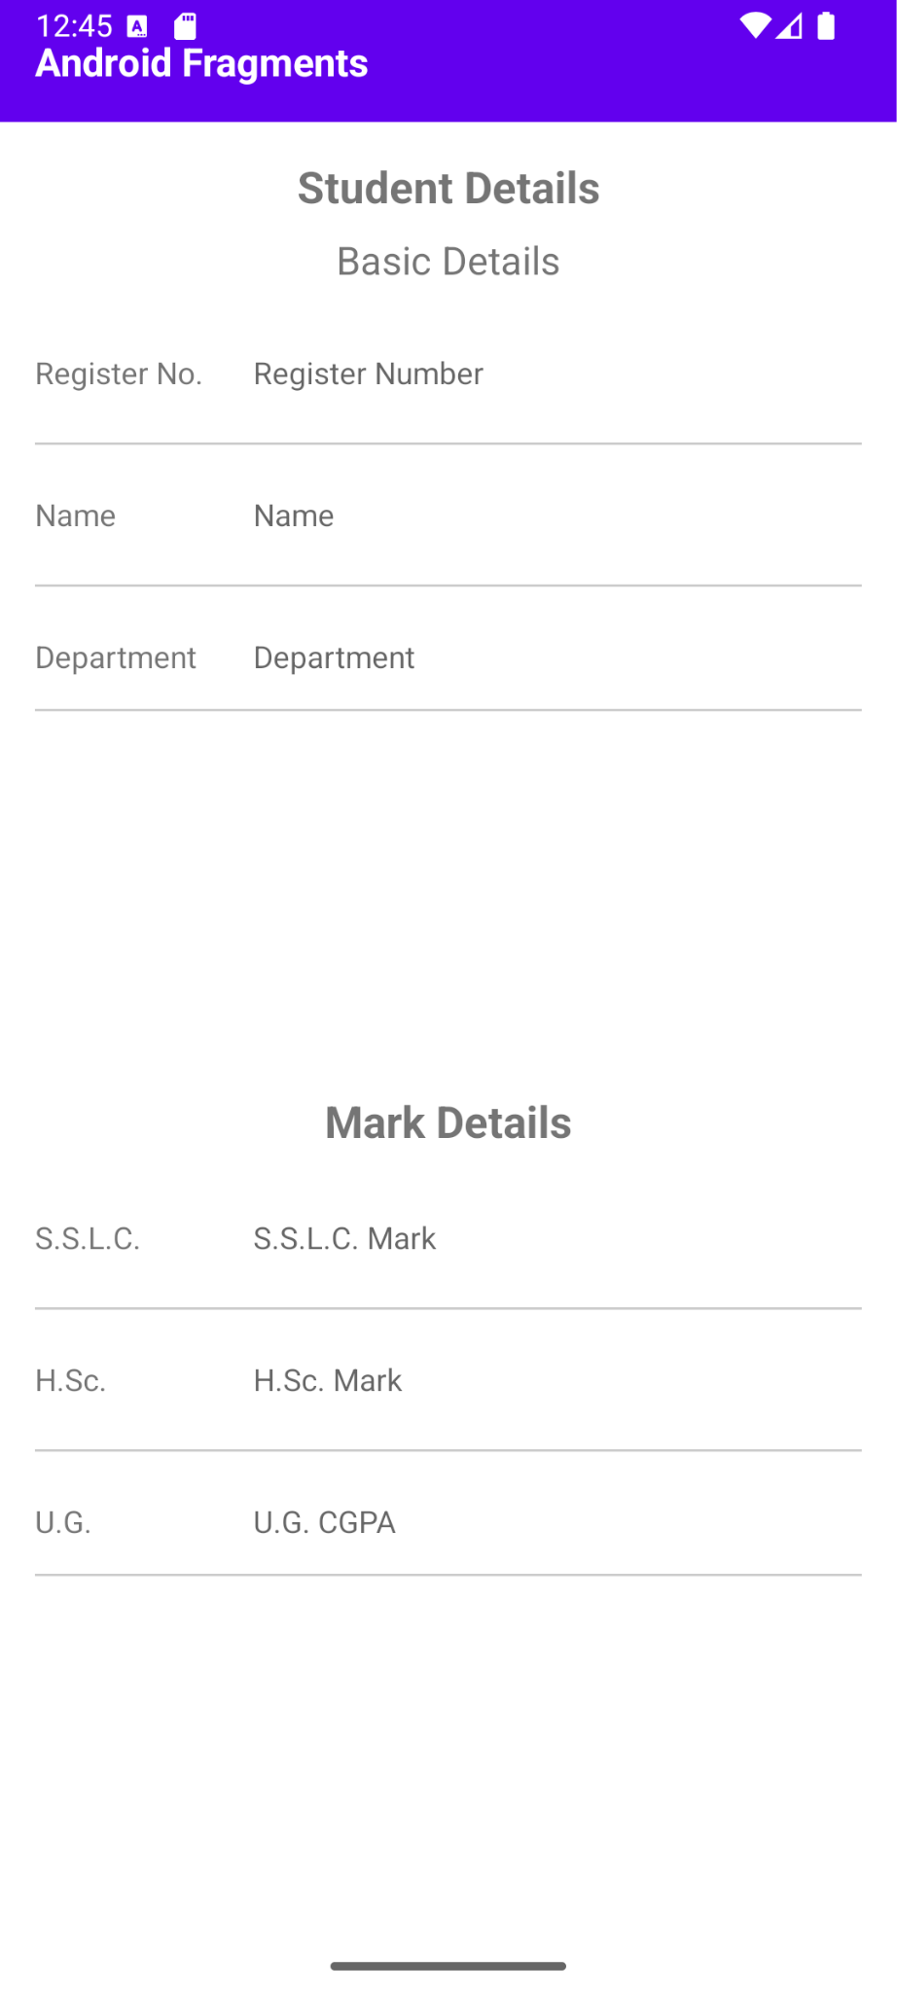

Result:
To design a Kotlin application that utilizes fragments to manage multiple UI components within a single activity.

